Lab 7

1-) Create a new DB called lab7.

Develop a RESTful Express Application for the following operations:

Find/FindOne/Add/Delete

for an entity called: lectures, users and students.

lectures = [{_id, course, lecture}]

users = [{_id, fname, lname, email, password}]

• Test your API using Postman

• Implement a route (GET /search/:q) to search if the lecture name contains the

passed :q parameter.

• Implement a route (GET /search?q) to search if the user fname contains the

passed :q parameter.

• Send the results as JSON.

• Return the same result object for each request

Get all

router.get('/', function (req, res) {

    req.db.collection('lectures').find().toArray()

        .then(data => {

            console.log(`search get method`)

            console.log(data)

            res.json({ status: "Success", data })

        })

        .catch(err => {

            res.json({ status: "Error" })

        })

})

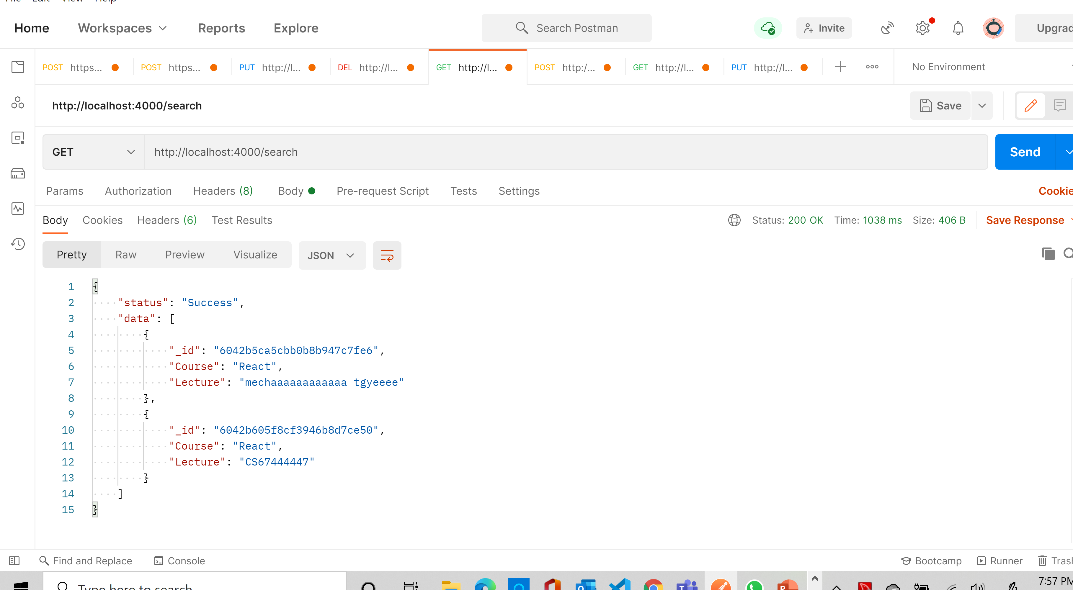

**Get one document**

router.get('/:id', function (req, res) {

    console.log('display single value')

    //req.db.collection('lectures').find({ '_id': new ObjectID(req.params.id) }).toArray().then(data => {

    req.db.collection('lectures').findOne({ '_id': new ObjectID(req.params.id) })

        .then(data => {

            res.json({ status: "Success", data })

        })

        .catch(err => {

            res.json({ status: "Error" })

        })

})

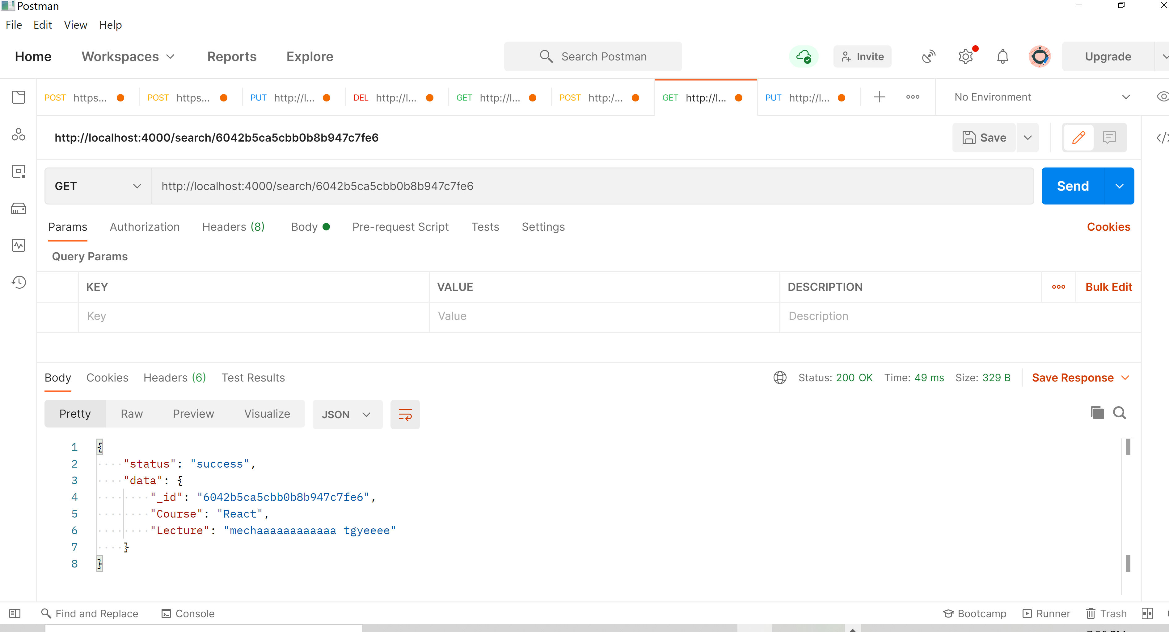

Post:

router.post('/', function (req, res) {

    req.db.collection('lectures').insertOne(req.body)

        .then(data => {

              res.json({ status: "Success" })

        })

        .catch(err => {

            res.json({ status: "Error" })

        })

})

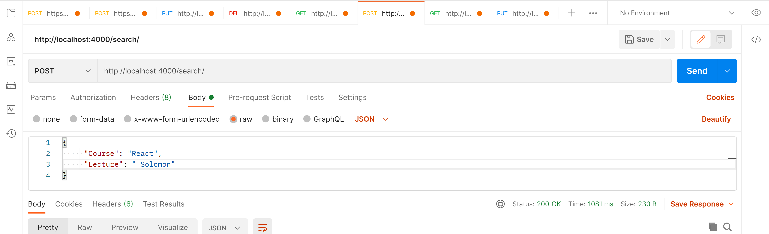

Put:

router.put('/:id', function (req, res) {

    req.db.collection('lectures').updateOne({ '_id': new ObjectID(req.params.id) }, { '$set': req.body })

        .then(data => { res.json({ status: "Success" }) })

        .catch(err => { res.json({ status: "Error" }) })

})

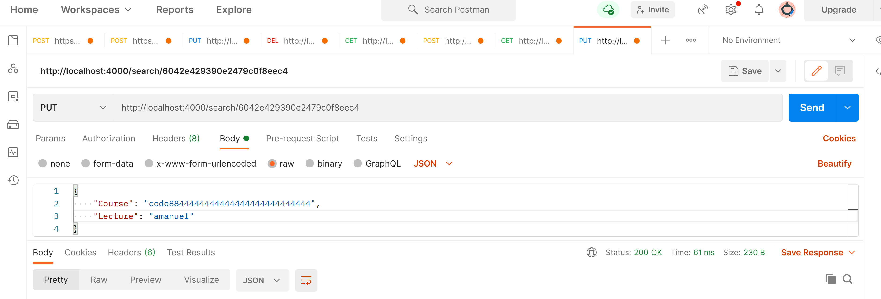

Delete

//delete

router.delete('/:id', function (req, res) {

    console.log('deleteeeeeeeeee')

    req.db.collection('lectures').removeOne({ '_id': new ObjectID(req.params.id) })

        .then(data => {

            if (err) throw err

            res.json('Delete');

        })

        .catch(err => {

            res.json('errrrr');

        })

})

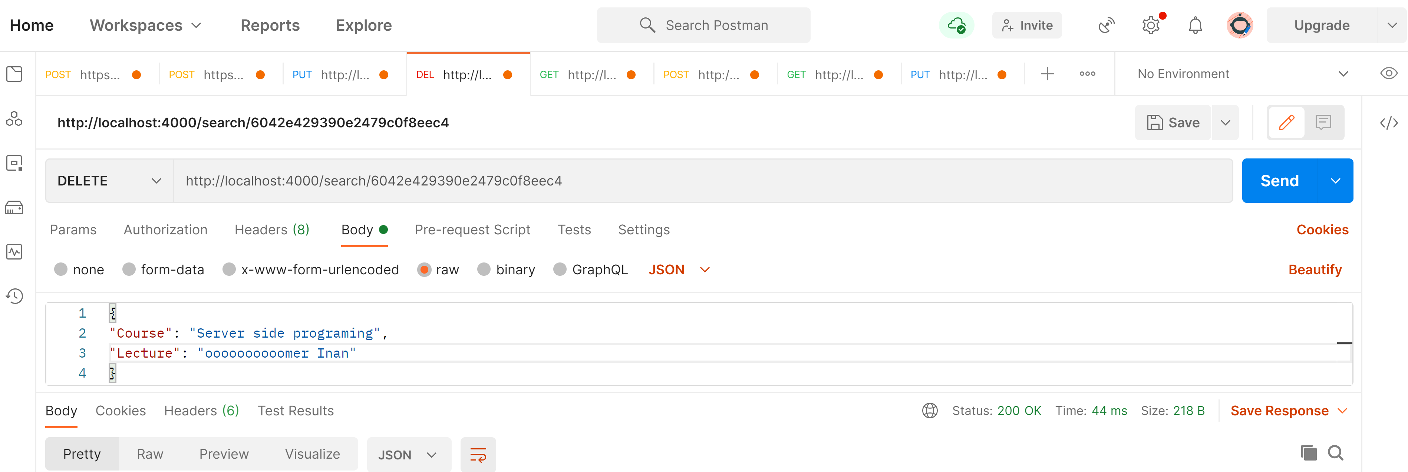

router.get('/:id', function (req, res) {

    console.log('display single value')

    //req.db.collection('lectures').find({ '_id': new ObjectID(req.params.id) }).toArray().then(data => {

    req.db.collection('lectures').findOne({ '_id': new ObjectID(req.params.id) }, { projection: { 'Lecture': 0 } })

        .then(data => {

            res.json({ status: "Success", data })

        })

        .catch(err => {

            res.json({ status: "Error" })

        })

})

